Press Release

FIVENORM – One Cable, Five Standards, Multiple Colour Options
HELUKABEL supplies single core cables in practical 100-metre cardboard boxes for export-oriented machine construction.

With its FIVENORM single core cables, HELUKABEL offers a simple and cost-effective solution for export-oriented machine and plant manufacturers. The copper cables with PVC insulation are certified according to all current approvals - and are also available in practical 100-metre cardboard boxes.

Hemmingen, January 12, 2022 – Plant and machinery manufacturers who export their products internationally are familiar with this challenge: each target market has its own standards and regulations to which all installed components must comply. Occasionally, this results in the need for increased inventory levels because many supplied parts are only certified according to one standard at a time. A machine that is sold on the European market as well as on the American and Asian markets may require three versions of one same part.
For cabling, HELUKABEL offers a simple and cost-effective solution with FIVENORM single core cables. The PVC insulated copper cables are certified according to all common approvals such as VDE, CSA, EAC, UL and MTW. This means that they can be used worldwide and, thanks in particular to the MTW (Machine Tool Wiring) listing, they are suitable for the entire mechanical engineering sector. Export-oriented companies therefore benefit from more efficient stockkeeping and a simplified list of parts.
The FIVENORM single core cables, manufactured in Germany to the highest quality standards, are available with multiple colour options. Smaller core diameters between 0.5 and 6 mm² are supplied by HELUKABEL not only using cable drums, but also in practical 100-metre cardboard boxes. This facilitates the handling of smaller quantities and in turn simplifies machine cabling. Even more, with FIVENORM single core cables, users benefit from an increased maximum conductor temperature of 90°C as well as an extended voltage range of up to 1,000 volts AC or 1,250 volts DC.
Find out more about HELUKABEL‘s FIVENORM single core cables:
www.helukabel.com/64075en
www.helukabel.com/64123en.
Meta-Title: HELUKABEL’s FIVENORM – One Cable, Five Standards, Multiple Colour Options

Meta-Description: With its FIVENORM single core cables, HELUKABEL offers a simple and cost-effective solution for export-oriented machine and plant manufacturers.

Keywords: HELUKABEL; FIVENORM; single core cables; cardboard box; machine and plant manufacturers; standards

This text contains 2,188 characters including spaces
Attachment: 2 Pictures
Please send a voucher copy to HELUKABEL.
Picture Captions:
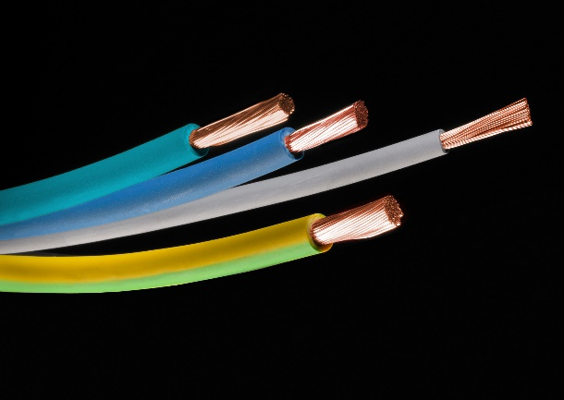
Bild 1: HELUKABEL’s FIVENORM single core cables are certified according to all common approvals such as VDE, CSA, EAC, UL and MTW and are therefore especially suitable for export-oriented machine and plant manufacturers. (Source: HELUKABEL)
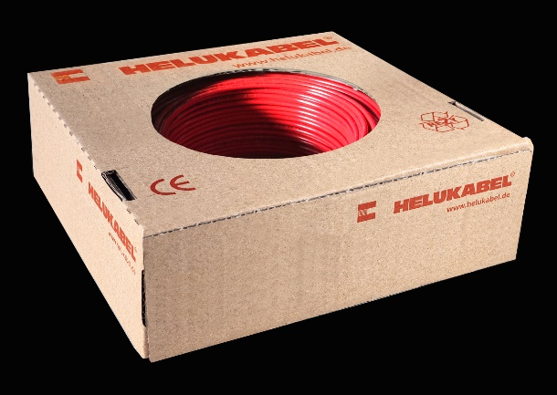
Bild 2: Smaller core diameters supplied by HELUKABEL also in practical 100-metre cardboard boxes. This facilitates handling and simplifies machine cabling. (Source: HELUKABEL)

About HELUKABEL
The HELUKABEL Group, headquartered in Hemmingen, Baden-Württemberg, Germany, is a leading international manufacturer and supplier of cables, wires and cable accessories. Founded in 1978, the family-owned company has developed broad expertise and deep knowledge of many industries and key technologies over the years. Today, HELUKABEL products and solutions are found in applications across multiple sectors including mechanical and plant engineering, industrial automation, oil and gas, building technology, infrastructure, mobility and renewable energy. With 58 locations and approximately 1,700 employees in 37 countries, the company is a reliable and responsive partner to its customers worldwide. They benefit from a comprehensive range of more than 33,000 stock items, a state-of-the-art logistics concept and expertise in the development of customized solutions. With this, HELUKABEL offers a complete portfolio of electrical connection technologies, all from a single source.

