Press Release

New Location in Norway: HELUKABEL Acquires Primatec
The HELUKABEL Group continues to expand internationally and, with its new subsidiary, now services all Scandinavian customers directly from their respective countries.

Hemmingen, February 9, 2022 – Expansion of the HELUKABEL group: The international supplier of cables, wires and accessories acquired a majority shareholding in the Norwegian company Primatec AS at the beginning of the year. HELUKABEL’s long-term distribution partner since 1998 has now become the 58th location of the corporate group and joins its strong international network.
Primatec is primarily known in its domestic market as a competent supplier of special cables and is recognized for its deep knowledge in the field of sensor technology. The company, based in Grimstad, south of Oslo, has its own warehouse of around 800 square metres, a test laboratory, and cutting and packaging technology. "Being a part of the HELUKABEL group will make us an even stronger partner for our customers and will provide access to new markets," explains Managing Director Cato Larsen. "Primatec and HELUKABEL are united by their great expertise in all matters related to cables. We already know from many decades of cooperation that our companies are a very good fit for each other."
With the new location in Norway and existing subsidiaries in Denmark and Sweden, HELUKABEL is now present throughout Scandinavia." As a result, our customers benefit from shorter delivery times and an even greater, more comprehensive service," emphasises Holger Weeber, Regional Sales Manager Nordic Countries. "We are very happy to welcome our new colleagues who are already very familiar with the Norwegian market, and, of course, with the HELUKABEL family."

Meta-Title: New Location in Norway: HELUKABEL Acquires Primatec

Meta-Description: The HELUKABEL Group continues to expand internationally and, with its new subsidiary, now services all Scandinavian customers directly from their respective countries.

Keywords: HELUKABEL; Group; Primatec; Acquisition; Subsidiary; Location; Norway; Scandinavia; Service; Cables; Sensor Technology

This text contains 1,751 characters including spaces
Attachment: 2 Pictures
Please send a voucher copy to HELUKABEL.

Picture Captions:
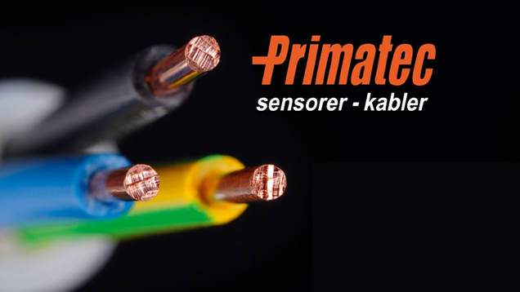
Picture 1: Expansion of the corporate group: HELUKABEL acquired a majority shareholding in the Norwegian company Primatec AS at the beginning of the year. (Source: HELUKABEL)
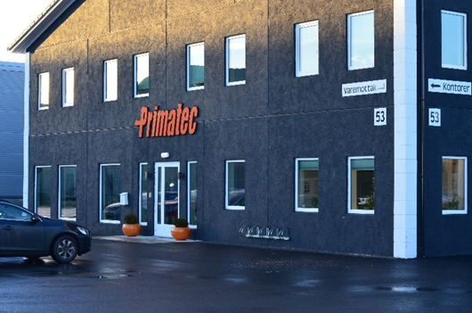
Picture 2: Primatec is a long-term distribution partner of HELUKABEL and known in its domestic market as a competent supplier of special cables with deep knowledge in the field of sensor technology. (Source: HELUKABEL)

About HELUKABEL
The HELUKABEL Group, headquartered in Hemmingen, Baden-Württemberg, Germany, is a leading international manufacturer and supplier of cables, wires and cable accessories. Founded in 1978, the family-owned company has developed broad expertise and deep knowledge of many industries and key technologies over the years. Today, HELUKABEL products and solutions are found in applications across multiple sectors including mechanical and plant engineering, industrial automation, oil and gas, building technology, infrastructure, mobility and renewable energy. With 58 locations and approximately 1,700 employees in 37 countries, the company is a reliable and responsive partner to its customers worldwide. They benefit from a comprehensive range of more than 33,000 stock items, a state-of-the-art logistics concept and expertise in the development of customized solutions. With this, HELUKABEL offers a complete portfolio of electrical connection technologies, all from a single source.

