Press Release

HELUKABEL acquires drag chain manufacturer ekd gelenkrohr
The specialist for electrical connection technology is taking another step towards becoming a system provider

Hemmingen, 28 February 2022 – The HELUKABEL Group is pleased to welcome a new member. At the beginning of 2022, the specialist for cables, wires and accessories acquired ekd gelenkrohr GmbH. In future, the company, based in Erkrath near Düsseldorf, will operate as a subsidiary of HELUKABEL under the name EKD Systems, and is now part of an international network of 59 sites in 37 countries.
Founded in 1970 by Ernst Klein, EKD specialises in developing and manufacturing customised energy chains made of steel, stainless steel and plastic. The company focuses on application-specific system solutions based on customer requirements, in small to medium quantities. To this end, the company has several machining centres, its own die and mould-making department and a fully automated plastic injection moulding department. "We are very happy to have achieved a succession plan with HELUKABEL, which will secure our team's jobs for the long term," explain previous owners Ansgar and Holger Klein.
For the company group, the acquisition is an important step towards becoming a system and solution provider. As of now, HELUKABEL is the only company in the world that manufactures both cables and wires as well as energy drag chains. "Our goal is to supply customers not only with individual components, but also with complete, pre-assembled and ready-to-use assemblies," says CEO Marc Luksch. "This means that the end users have less work to do and can turn to one contact partner for all their questions related to connection technology." Custom-made products have always been a speciality at HELUKABEL. "Our new subsidiary is an ideal member to grow our portfolio in this area," confirms Luksch.

Meta Title: HELUKABEL acquires drag chain manufacturer ekd gelenkrohr

Meta Description: The specialist for electrical connection technology is taking another step towards becoming a system provider.

Keywords: HELUKABEL; Group; ekd gelenkrohr, EKD Systems; Acquisition; Subsidiary; Drag chains; Energy drag chains; Energy chains; Cables; Wires; Assemblies; System provider; Solution provider

This text contains 1,858 characters including spaces
Attachment: 2 Pictures
Please send a voucher copy to HELUKABEL.

Picture Captions:
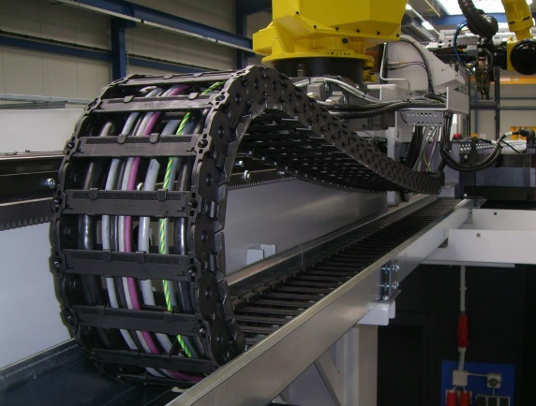
Picture 1: With its acquisition of EKD Systems, HELUKABEL is the only company in the world that manufactures both cables and wires as well as energy drag chains. (Source: HELUKABEL)

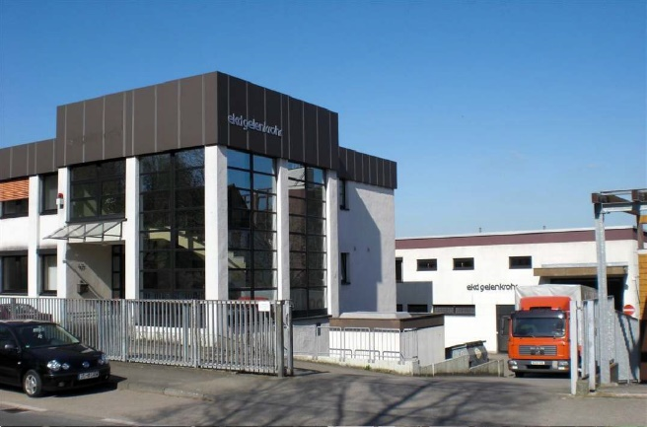
Picture 1: The HELUKABEL Group acquired ekd gelenkrohr GmbH, based in Erkrath near Düsseldorf, at the beginning of 2022. (Source: HELUKABEL)

About HELUKABEL
The HELUKABEL Group, headquartered in Hemmingen, Baden-Württemberg, Germany, is a leading international manufacturer and supplier of cables, wires and cable accessories. Founded in 1978, the family-owned company has developed broad expertise and deep knowledge of many industries and key technologies over the years. Today, HELUKABEL products and solutions are found in applications across multiple sectors including mechanical and plant engineering, industrial automation, oil and gas, building technology, infrastructure, mobility and renewable energy. With 59 locations and approximately 1,700 employees in 37 countries, the company is a reliable and responsive partner to its customers worldwide. They benefit from a comprehensive range of more than 33,000 stock items, a state-of-the-art logistics concept and expertise in the development of customized solutions. With this, HELUKABEL offers a complete portfolio of electrical connection technologies, all from a single source.

