Press Release

A Focus on Complete Solutions for Automation Technology
HELUKABEL Acquires Cable Assembler Sangel Systemtechnik

Hemmingen, 27 April 2022 – A new addition to the HELUKABEL Group: at the end of March 2022, the specialist for cables, wires and accessories acquired Sangel Systemtechnik GmbH. The company, with its headquarters in Bielefeld, Germany and another location in Plovdiv, Bulgaria, is therefore the latest member of the globally active group of companies.
Since its foundation in 1996, Sangel Systemtechnik has developed into one of the leading manufacturers of high-quality industrial cable assemblies and complete system assemblies for machine and plant construction. The company has already been working closely with HELUKABEL for many years. "We are looking forward to further intensifying our partnership, and through resulting synergies to meet the ever-increasing demands of our customers," explains Managing Director Frank Sangel, who, alongside the rest of the management team, will remain on board.
For HELUKABEL, the acquisition of Sangel is meaningful to its product portfolio and is a further step towards becoming a system provider. "Our goal is to further expand our offer of customised comprehensive solutions, especially for drive and automation technology – also in cooperation with our subsidiaries Robotec Systems and EKD Systems," emphasises Managing Director Marc Luksch. "In addition, the new partnership enables us to broaden our international activities in cable assembly – from Europe to Asia to North America."

Meta-Title: HELUKABEL Acquires Cable Assembler Sangel Systemtechnik

Meta-Description: The specialist for cables, wires and accessories takes a further step towards becoming a system provider.

Keywords: HELUKABEL; Group; Sangel Systemtechnik; Acquisition; Subsidiary; Cables; Wires; Cable assembly; Assemblies; System provider; Solution provider; Automation; Drive technology

This text contains 1,540 characters incl. spaces
Attachment: 3 images
Please send a voucher copy to HELUKABEL.

Image Captions
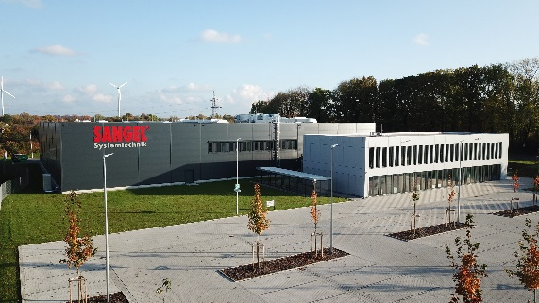
Image 1: At the end of March 2022, HELUKABEL acquired Sangel Systemtechnik GmbH. (Source: HELUKABEL)

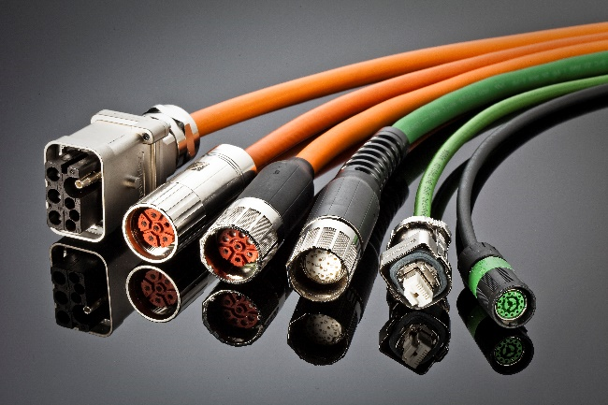
Image 2: Sangel Systemtechnik is one of the leading manufacturers of high-quality industrial cable assemblies and complete system assemblies for machine and plant construction. (Source: HELUKABEL)

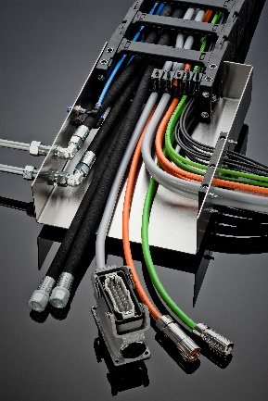
Image 3: Through the acquisition, the HELUKABEL Group takes a further step towards becoming a system provider. (Quelle: HELUKABEL)

About HELUKABEL
The HELUKABEL Group, headquartered in Hemmingen, Baden-Württemberg, Germany, is a leading international manufacturer and supplier of cables, wires and cable accessories. Founded in 1978, the family-owned company has developed broad expertise and deep knowledge of many industries and key technologies over the years. Today, HELUKABEL products and solutions are found in applications areas including mechanical and plant engineering, industrial automation, oil and gas, building technology, infrastructure, mobility and renewable energy. With 60 locations and more than 1,900 employees in 37 countries, the company is a reliable and responsive partner to its customers worldwide. They benefit from expertise in the development of customized solutions, a comprehensive range of more than 33,000 stock items and a state-of-the-art logistics concept. HELUKABEL’s operations include manufacturing and testing facilities, where maintaining the highest standards of quality is a top priority. Altogether, HELUKABEL offers its end-users complete solutions for electrical connection technology, all from a single source.

